[1]

Head-operated Button System for Wheelchair Control in Patients with Spinal Cord Injury

R. Alarcón, N. Asto, E. J. Ochoa, R. Postigo, A. Sáenz Fundamentos de Biodiseño 2019-2, Ingeniería Biomédica PUCP-UPCH

*Abstract*—More than half of patients with spinal cord injury (SCI) report pain in the upper extremity (UE), such as hand, wrist, elbow and shoulder. This pain is mainly associated with wheelchair mobility. In recent years, numberless wheelchair control mechanisms have been developed as an alternative to the use of UEs. In this project, we aimed to develop a device that allowed SCI patients to control their wheelchairs without the risk of a UE injury. We use the head motion as an alternative to the move of arms. Our device consists of a two-push button system, located around the head, that will allow the patient to perform traction and rotation movements in the wheelchair.

***Index Terms***—**Assistive technology, powered wheelchair, upper extremity pain, spinal cord injuries, independent mobility**

# Introduction

National Spinal Cord Injury Statistical Center (NSCISC) reports that SCI incidence has risen from 40 to 54 cases per million between 2015 and 2019 in the United States (US) (1). This is the equivalent of 17,700 new SCI cases each year. SCIs are one of the most common leading conditions related to wheelchair use (2). Over 90% of wheelchair users have a manual wheelchair (3). Manual wheelchair mobility requires the use of the upper body for maneuvering the wheelchair and performing transfers, weight reliefs and activities of daily living. However, the UE is not intended for this magnitude or frequency of loading, and these activities commonly lead to the development of pain and pathologies such as carpal tunnel syndrome, rotator cuff tears, and shoulder impingement (4). Specifically, chronic pain in UE has an important impact on patients with SCI. Full-time employment rate drops from 45.2 to 20.0% in SCI patients with UE pain, while the unemployment rate rises from 7.1 to 21.4 percent (5). This translates into an economic loss to the patient and the State. Ataog˘lu et al. (6) reported that mood and quality of life are negatively affected by pain in SCI patients. Additionally, it was found that SCI patients with chronic pain had higher depression ratings.

Bayley et al. (7) reported a 30% incidence of shoulder pain in SCI patients while a 51% prevalence was found by Nichols et al. (8). Subbarao et al. (9) studied the incidence of shoulder and wrist pain in SCI patients and reported that it was higher than previously reported: 72.7 percent of patients had some degree of chronic pain in one or both of these areas. This high figure could be attributed to a high average number of years since injury (22.8 years) as Subbarao et al. and Gellman et al. (10) reported that UE pain increased with time since injury. In a more complete investigation, Daylan et al. (5) reported a 58.5% of patients suffering from UE pain including shoulder, elbow, wrist and hand. Studies have concluded that UE pain is more likely to be associated with transfers and wheelchair propulsion and propose that future research should focus on new methods of wheelchair propulsion that lessen stress and cumulative trauma on the wrist and shoulders (10). Additionally, Daylan et al. (5) found that, after home modification (*Very helpful* in 63.6% of the cases), wheelchair modification is the second most effective treatment (*Very helpful* in 54.5% of the cases); however, it was one of the less common treatments (Only after surgery and acupuncture).

Nowadays, varied investigations have focused on developing new electric wheelchairs or wheelchair modifications that can substitute the UE effort with electronic mechanisms. Kim et al. (11), students from the Georgia Institute of Technology, developed a wireless and wearable assistive technology that enables people with disabilities to control their smartphones, computers and wheelchairs. This was called Tongue-Drive System (TDS). The TDS consists of a magnetic stud located inside the mouth that could provide a signal to a magnetic sensor on the outside in order to use the voluntary tongue motion to perform daily life actions such as phone dialing or wheelchair mobility. Guo et al. (12) developed a chin-operated force-sensing powered wheelchair joystick. This was aimed to allow wheelchair movement in patients with no UE motion. Wanluk et al. (13) worked on a project that consists of a smart wheelchair based on eye-tracking. It uses a webcam installed on the eyeglass and C++ customized imagen processing software, which allows the patients to give directions to the wheelchair. Chauhan et al. (14) and Puviarasi et al. (15) developed low-cost wheelchairs controlled by voice. Oonishi et al. (16) developed a power-assisted wheelchair that measures the human applied torque with an electromyogram (EMG) sensor, calculates the assisted torque and amplifies the input force with electric motors.

Most of the devices showed in the state of art require severe modifications in the wheelchair and certain training by the patient to adequate to the sensors. Furthermore, wheelchair powerpacks prices are in a range of $381 to $2,842 (1,292 to 9,632 soles) and power wheelchairs have an average price of $26,404 (89,465 soles) (17). In this project, we developed a mechanism that could be easily adapted to any manual wheelchair and will allow the patient to control the wheelchair using head motion as an alternative to the use of the UEs. It consists of a low-cost push-button system located on the top of the wheelchair, around the head. The user will be able to perform traction and rotation movements in the wheelchair with minimum effort and training, without the risk of suffering a UE injury.

# Design Specifications

Based on the compiled information, we specified some requirements for the device design.

* Accessibility: Taking into account the socio-economic context of our country, the proposal must be a low-cost device. A $200 (679 soles) total cost was considered acceptable.
* Intuitiveness: The user should be capable of using the device with minimum training and effort.
* Adaptability: It must be easily adaptable to any wheelchair and patient dimensions.
* Autonomy: The patients must be able to use the device with minimum help depending on their neurologic levels.
* Ergonomics: The button header should adapt comfortably to the shape of the head.
* Power: According to Kakimoto et al. (18), a maximum of 165 watts (W) of power are needed in order to propel a wheelchair with a regular-weighted person.
* Speed: The device is intended for indoor use. Rebsamen et al. (19) found 0.5 meters per second (m/s) as an acceptable maximum speed.

We divided the device into two principal modules. The *control module* will be located behind the head. This first unit consists of a button arrangement supported in the wheelchair header. The second component of the device will be the *traction module*. This module will be in charge of receiving the first module commands and performing the motion tasks.

# DEVICE DESIGN

## A. Control Module

After analyzing the necessary function and ergonomics in the header, we concluded that the walls must have a curve shape, so it can adjust to the head and the user. This will reduce the made by the user to push the buttons. This one-piece wall was designed with a specific pattern in laser cutting. This pattern will allow it to have flexibility and molding. Inside of the header will be located all the electronic circuits. The circuit diagram is shown in Fig. 1. The main controller is an Arduino Mega 2560. In order to control the traction module, a Monster Moto Shield VNH2SP30 driver was used.

## B. Traction Module

This module was based on the car’s rear-wheel drive mechanism. In this system, the motor transmits power through a pair of bevel gears to the wheels axis. Fixed but simple support was sought for the support. The final design was a cubic box without two opposite faces in order to show the module intern functioning. The box function will be to support the battery and motor. A 24V DC conventional motor of 180W was employed. This distribution is shown in Fig. 2.

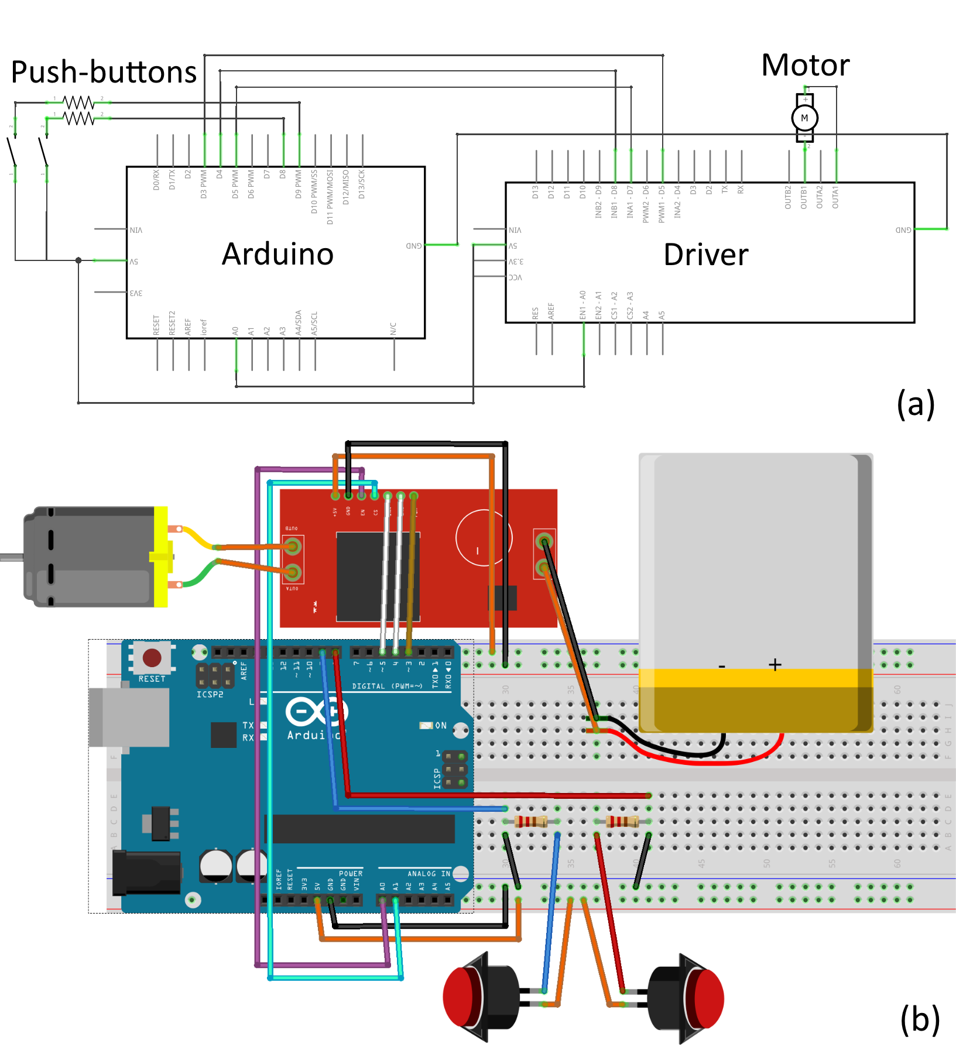

Figure 1. Circuit diagram: (a) Schematic view, (b) On protoboard view.

# Device Fabrication

## A. Control Module

A fundamental part of this module fabrication was the implementation of the header (Fig. 3) to the wheelchair. Due to its size, 3D printing was discarded in the principal piece.

Laser cutting was the fabrication method we finally chose. Header fabrication was divided into two main parts.

Bottom part:

1. Fasteners to the wheelchair handle: These two pieces were made 3D printing. Their function is to adjust the system to the handle of the wheelchair to prevent it from slipping backward.

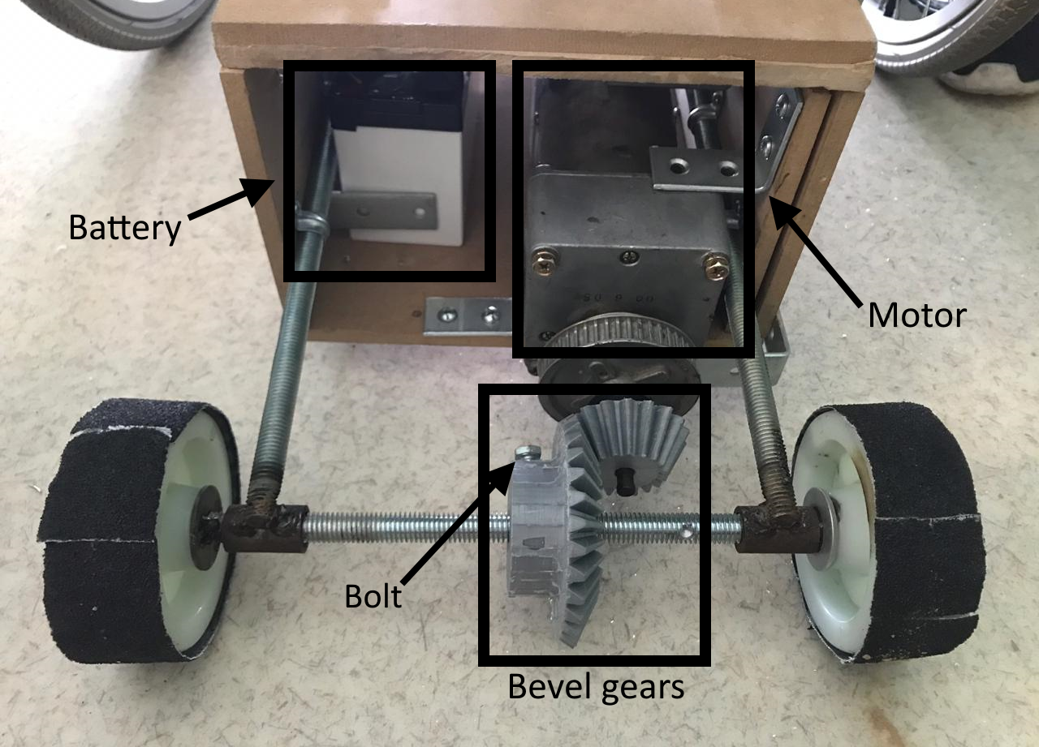

## Figure 2. Traction module distribution.

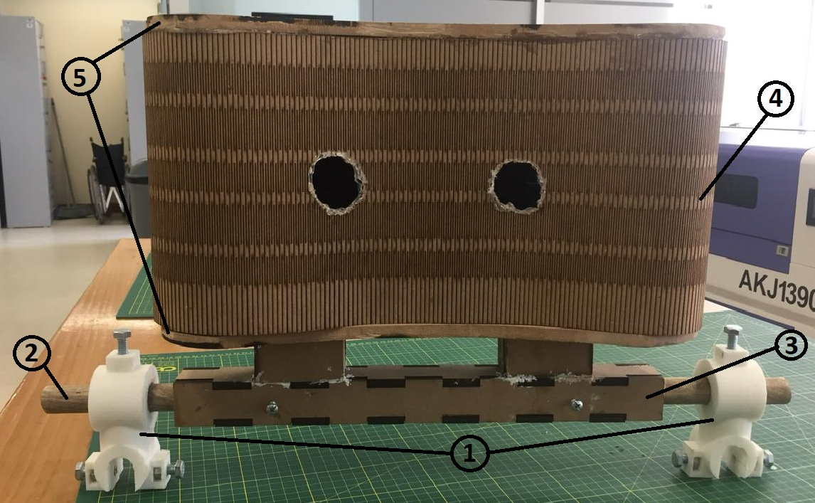

Figure 3. Control module parts.

1. Rod: A regular wooden rod. It has a diameter of 2.2 cm and a length of 60 cm. Its function is to attach the support that contains it to the fastener. In addition, it will allow the distance between the fasteners to vary, being adjusted using bolts to the rod, thus making it adaptable to any wheelchair width.
2. Support that contains the rod: It is made of 4 joined 0.3 cm MDF (Medium Density Fiber) pieces that enclose the rod. Its function is to hold the bar and support the weight of the upper part

Upper part:

1. Flexible wall: Made in laser cutting. It has a length of 100 cm, and a height of 20 cm.
2. Header caps: Roof and floor of the header are assembled together with the flexible wall. The floor is attached to the rod support.

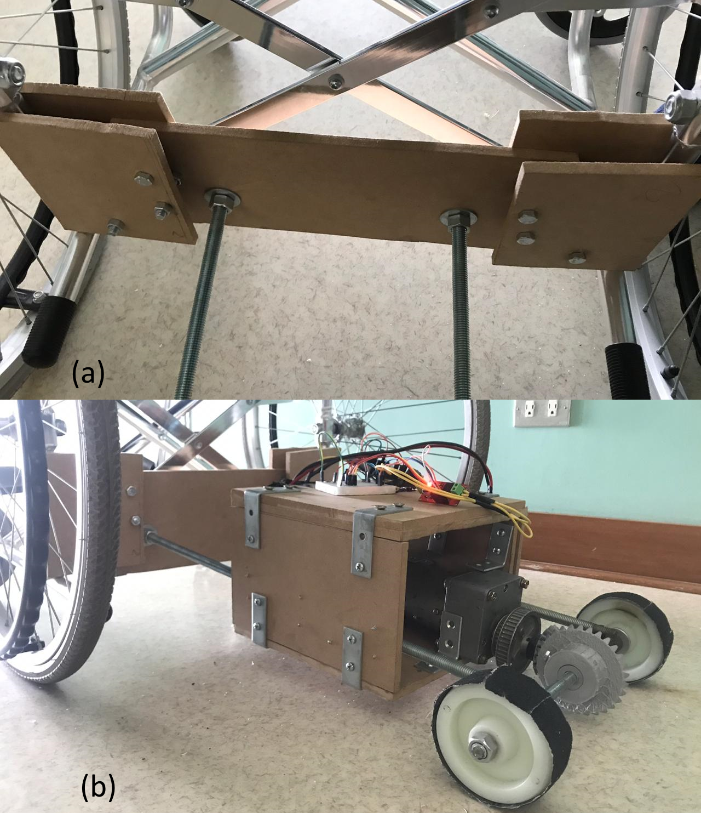

Figure 4. (a) Union between the traction module and the wheelchair. (b) Lateral view of the traction module.

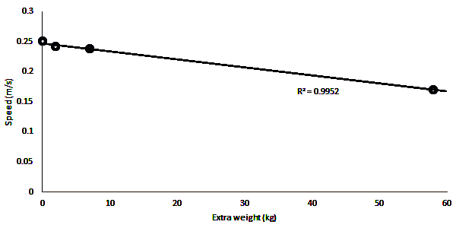

## Figure 5. Maximum speed measured at different weights using a 12V battery.

## B. Traction Module

The box was made with laser cutting in MDF due to its rapid manufacturing at prototyping and validating concepts. For the shaft, a metal rod was used together with welding and cutting in a mechanical workshop. The two wheels necessary for the movement were welded to the shaft, and the wheels were sanded for greater friction with the floor. The faces of the box were joined with bolts and screws. To the lateral faces were added two metal rods that would allow the support of the box and the union between the shaft and the wheelchair (Fig. 4). The construction of the bevel gears was done with 3d printing, and a hole between the wheel shaft and the larger gear was drilled and bolted so that there is no slippage.

# Results

In order to characterize the final prototype, maximum velocity and current tests were performed.

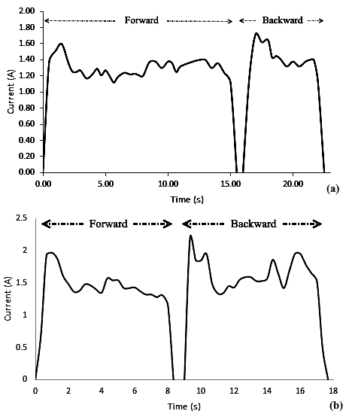

Figure 6. Current vs time graphic: (a) No extra weight, (b) 58 kg of extra weight.

Although we used a 24V motor, both of these tests were carried out with a 12V battery. The graphic in Fig. 5 shows the measured speed of the device pushing a 15 kg wheelchair carrying different weights. The maximum speed was 0.25 and 0.17 m/s with 0 and 58 kg of extra weight respectively.

The current was measured using an ammeter. Fig. 6 shows the variation of current as a function of time with 0 and 58 kg of extra weight. Every test was performed forward and backward. The maximum measured value of current was respectively 1.60 and 1.72A in forward and backward motion with no extra weight. Carrying a 58 kg person, maximum current rose up to 1.97 A in forward motion, while in backward motion, current came up to 2.20 A.

# Discussion

The final prototype (Fig. 7) was tested in some of the authors of this paper. Participants reported comfort while using the device due to the minimum effort required to push the buttons. Several trials reveal that there is no pain on the neck or shoulders due to excessive use of the device. Participants considered the experience as fun and enjoyable. Regarding the price, counting manufacturing time (laser cutting and 3d printing), 545 soles ($160) were spent in the fabrication process of the device. This price is within the range proposed in the design specifications.

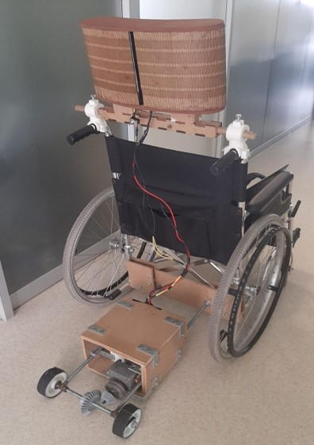

Figure 7. Final device implementation

After measuring the maximum speed, the speed given in the design specifications was not reached. However, this could be explained because the motor was not functioning at its optimum voltage (24V). Moreover, according to Rebsamen et al. (19), people who can’t move at all are normally stuck in bed; their notion of time differs from ours, and being able to move independently within their environment represents a much-improved quality of life, whether it takes time or not. In this context, safety and reliability are much more important than speed.

Since the motor has a maximum amperage that it can withstand, we consider it convenient to perform a current measurement as a safety precaution for both the motor and the user. When analyzing the current vs. time graphics, it can be observed that current peaks occur at the beginning of the movement. This coincides with the theory because, in order to remove an object from its resting state, it is necessary to overcome inertia, and therefore, more current is required. Moreover, in both tests, more current was needed to perform backward motion. This can be explained due to the slight vertical inclination of the traction module (Fig. 4b).

The employed motor can withstand a current up to 7.5 A and the maximum measured current was 2.20 A. Taking a linear behavior in the ratio of current/extra weight, the employed motor can withstand a person three times heavier than the participant (58 kg). Nonetheless, tests were not performed with more extra weight due to the 3D-printed bevel gears. PLA is a relatively resistant material; however, it can’t withstand that much torque and tends to crack. Additionally, the bolt that fixes the gear with the wheels shaft also tends to slip when too much weight is applied.

# Conclusions and Perspectives

Nowadays, SCIs are a rising problem in our society. Furthermore, due to its high incidence and impact, UE pain is one of the more important complications in SCI patients. According to the NSCISC (1), only 12.3% of all patients with SCI are complete tetraplegic. We developed a device that would allow patients with complete tetraplegia, who can’t move at all, to regain independence in their movement, and would prevent UE pain and injuries in paraplegic and incomplete tetraplegic patients. The developed device meets the design specifications and has an approximated cost of $160. A maximum speed of 0.17 m/s carrying a person of 58 kg was measured. For further projects, we recommend the use of aluminum gears for more resistance and wider fasteners for more stability in the header. The header size can still be reduced in order to be more portable and lightweight.

REFERENCES

1. National Spinal Cord Injury Statistical Center, Facts and Figures at Glance. University of Alabama at Birmingham. 2015-2019.
2. Kaye H S, Kang T, LaPlante, M P. Mobility Device Use in the United States. Disability Statistics Report, (14). Washington, D.C.: U.S. Department of Education, National Institute on Disability and Rehabilitation Research. 2000.
3. Slavens B, Graf A, Krzak J, Vogel L, Harris G. Upper extremity wheelchair kinematics in children with Spinal Cord Injury. 2011 Annual International Conference of the IEEE Engineering in Medicine and Biology Society. 2011.
4. Schnorenberg A, Slavens B, Graf A, Krzak J, Vogel L, Harris G. Upper extremity biomechanics of children with spinal cord injury during wheelchair mobility. 2014 36th Annual International Conference of the IEEE Engineering in Medicine and Biology Society. 2014.
5. Dalyan M, Cardenas D, Gerard B. Upper extremity pain after spinal cord injury. Spinal Cord. 1999;37(3):191-195.
6. Ataoğlu E, Tiftik T, Kara M, Tunç H, Ersöz M, Akkuş S. Effects of chronic pain on quality of life and depression in patients with spinal cord injury. Spinal Cord. 2012;51(1):23-26.
7. Bayley J, Cochran T, Sledge C. The weight-bearing shoulder. The impingement syndrome in paraplegics. J Bone Joint Surg. 1987;69(5):676-8.
8. Nichols P, Norman P, Ennis J. Wheelchair user's shoulder? Shoulder pain in patients with spinal cord lesions. Scand J Rehab Med. 1979;11(1):29-32.
9. Subbarao J, Klopfstein J, Turpin R. Prevalence and Impact of Wrist and Shoulder Pain in Patients with Spinal Cord Injury. The Journal of Spinal Cord Medicine. 1995;18(1):9-13.
10. Gellman H, Sie I, Waters R. Late Complications of the Weight-Bearing Upper Extremity in the Paraplegic Patient. Clinical Orthopedics and Related Research. 1988;(233):132-135.
11. Kim J, Park H, Bruce J, Rowles D, Holbrook J, Nardone B et al. Assessment of the Tongue-Drive System Using a Computer, a Smartphone, and a Powered-Wheelchair by People with Tetraplegia. IEEE Transactions on Neural Systems and Rehabilitation Engineering. 2016;24(1):68-78.
12. Guo S, Cooper R, Boninger M, Kwarciak A, Ammer B. Development of power wheelchair chin-operated force-sensing joystick. Proceedings of the Second Joint 24th Annual Conference and the Annual Fall Meeting of the Biomedical Engineering Society. 2002.
13. Wanluk N, Visitsattapongse S, Juhong A, Pintavirooj C. Smart wheelchair based on eye tracking. BMEiCON. 2016.
14. Chauhan R, Jain Y, Agarwal H, Patil A. Study of implementation of Voice Controlled Wheelchair. 2016 3rd International Conference on Advanced Computing and Communication Systems (ICACCS). 2016.
15. Puviarasi R, Ramalingam M, Chinnavan E. Low Cost Self-Assistive Voice Controlled Technology for Disabled People. IJMER. 2013;3(4):2133-2138.
16. Oonishi Y, Oh S, Hori Y. A New Control Method for Power-Assisted Wheelchair Based on the Surface Myoelectric Signal. IEEE Transactions on Industrial Electronics. 2010;57(9):3191-3196.
17. Ward A, Sanjak M, Duffy K, Bravver E, Williams N, Nichols M et al. Power Wheelchair Prescription, Utilization, Satisfaction, and Cost for Patients with Amyotrophic Lateral Sclerosis: Preliminary Data for Evidence-Based Guidelines. Archives of Physical Medicine and Rehabilitation. 2010;91(2):268-272.
18. Kakimoto A, Matsuda H, Sekiguchi Y. Development of power-assisted attendant-propelled wheelchair. Proceedings of the 19th Annual International Conference of the IEEE Engineering in Medicine and Biology Society 'Magnificent Milestones and Emerging Opportunities in Medical Engineering' (Cat No97CH36136). 1997.
19. Rebsamen B, Burdet E, Guan C, Zhang H, Teo C, Zeng Q et al. Controlling a Wheelchair Indoors Using Thought. IEEE Intelligent Systems. 2007;22(2):18-24.

1.